**Estore**

**for: Delta enterprises Limited  
Project Scope**

****15/12/2022****

**Overview**

1. **Project Background and Description**

The DELTA ENTERPRISES LIMITED was Incorporated on 23rd Apr 2003 as a public limited company and has been thriving in Kisumu ever since, progressively over the years. It has its main branch in Kisumu Central, Kisumu County.

The company has been working on manual basis ever since and has been experiencing challenges in the efficiency with which they serve their customers. There have been long queues since customers would come and wait to be served and this leads to time wastage and slow service rates.

The enterprise continues to advance and expand to meet its customers’ needs with ease and this calls for the need to automate the manual processes that is the norm of its operation. The automation will help in the following ways: -

* It will hasten the operation processes.
* It will increase the service rate of the business enterprise.
* It will help maintain a good customer relationship or customer base since the customers wouldn’t wait and get bored with long queues.
* It will make the company be at per with the general world where everything is automated.
* This will reduce the total shopping time a great deal.

1. **Project Scope**

The proposed system will be a responsive Web Application that will be accessible over the internet through after being hosted by the company: - This will be accessible through laptops or desktops, smartphones, tablets or any other device with a browser and supports any search engine.

The project mainly will have two modules which will be:

* The Customer Module
* The Management or Admin Module

***Customer Module***

The Customer module will include: -

* New customer registration, login and storage of the customer details in the database
* Addition to the cart functionality.
* Edit the cart or remove the items selected.
* The customer will be able to view the items that have been selected or the available items
* The customer will be able to checkout and choose a delivery address
* The customer will be able to choose a payment mode or method.

|  |  |  |  |
| --- | --- | --- | --- |
| # | CUSTOMER OPERATION | REQ. | ACCESS |
| 1 | Register customers | Form | system |
| 2 | Login | Form | System |
| 3 | View Online Item List | Auto | System |
| 4 | Pick a Delivery Address | NA | System |
| 5 | Choose Payment Method | YES | System |
| 6 | Logout | YES | System |
| 7 | View the Catalog | YES | System |
| 8 | View the item Details and Specifications | YES | System |

***Admin/ Management Module***

The admin will have the following functionalities: -

* The admin will be able to alter and change the payment methods
* The admin will have the admin dashboard.
* The admin will be able to add items in the shopping list to be viewed by the customers over the internet.
* The Manager will be able to ads item details through the admin dashboard.

|  |  |  |  |
| --- | --- | --- | --- |
| # | ADMIN/ MANAGEMENT OPERATION | REQ. | ACCESS |
| 1 | Provision supper user | NA | System |
| 2 | Edit the payment method | YES | System |
| 3 | Add items and Item Details | YES | System |

1. **High-Level Requirements**

The system is web based application. As such, any device with internet access and the latest browser, will be able to access it. In addition, there will be SMS capabilities that can be utilized by any device with SMS capabilities.

The new system must include the following:

* Ability to allow both internal and external users to access the application without downloading any software
* Ability to interface with the existing data warehouse application
* Ability to incorporate automated routing and notifications based on business rules

1. **Deliverables**

* UI Prototype for both Potential Customers and Admin or the Management.
* An accessible responsive Web Application for potential customers and the Management
* User documentation manual.
* Technical documentation.
* Installation instructions.
* Success levels
* Conclusions
* Recommendations

1. **Affected Parties**

* Potential Customers
* Admin/ Management

1. **Affected Business Processes or Systems**

* Customer Registration
* Making of orders
* Logging in or signups
* Checkout Process
* Payment Methods
* Addition of list items and item details of each item

1. **Specific Exclusions from Scope**

In this phase (1St phase), the following will be excluded and will come in the subsequent phases in the development process in future: -

* Direct MPESA payment and connection through the API, that will enable real-time deposit reflection into the customers’ profile and transaction details.
* The actual Credit Card payment over the internet and reflection to the customers’ transaction details.
* Integration with the existing systems e.g. other online stores (jiji).
* Email and SMS notification of orders
* Tracking of deliveries.

1. **Implementation Plan**

The project development will start once the necessary environment is set and the user interface sketch and prototypes are developed.

The management of the company will have the chance to give insights and critiques on the improvements to be made on the system after seeing the user interface (UI) sketches and the prototype.

All these will ensure that all functionalities that are required by the company are factored in and are implemented in the final system to assure a near-perfect user experience (UX) on the system.

The customer module will follow next after the user interfaces prototypes and this will need the implementation of the logic in the system. Later the Management module with the admin dashboard will be last in the implementation process. Training of the users on how to use the system and the shifting/ Conversion to the new system will be the final stage of the whole process

1. **High-Level Timeline/Schedule**

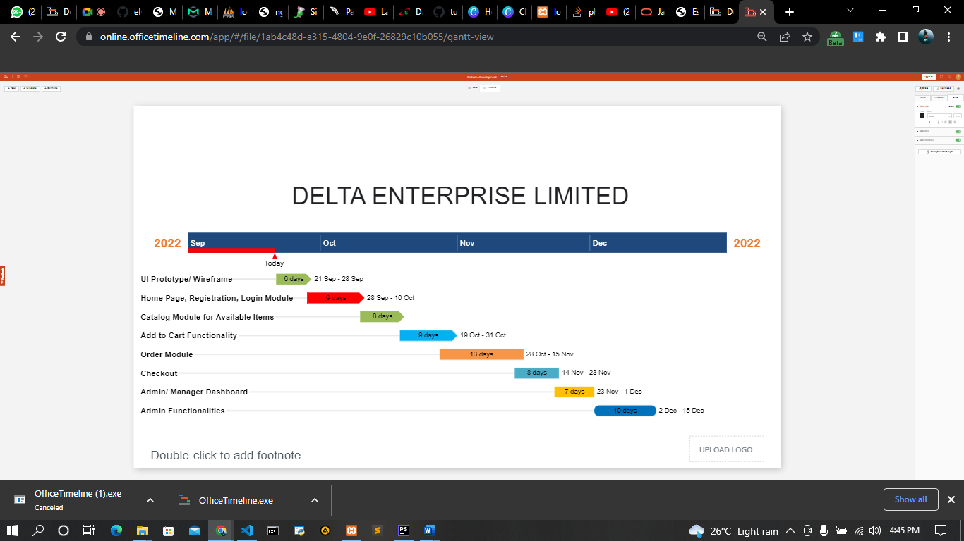

**Approval and Authority to Proceed**

We approve the project as described above, and authorize the team to proceed.

|  |  |  |  |
| --- | --- | --- | --- |
| Name | Title | Signature | Date |
| Felix Otieno Okoth | Mr. |  | 15/12/2022 |
|  |  |  |  |

|  |  |  |  |  |  |  |  |  |
| --- | --- | --- | --- | --- | --- | --- | --- | --- |
|  |  |  |  |  |  |  |  |  |
| Approved By |  |  | Date |  | Approved By |  |  | Date |